**Master Data Preparation with Dataiku | Comprehensive Recipe**

Next

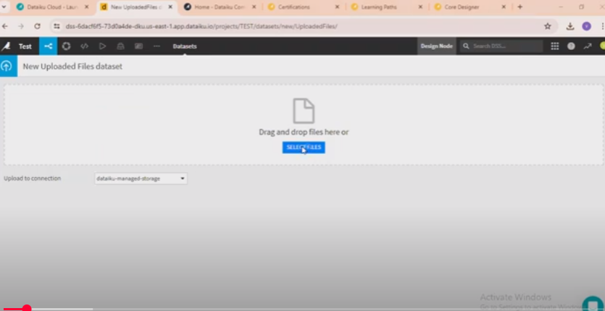

Next

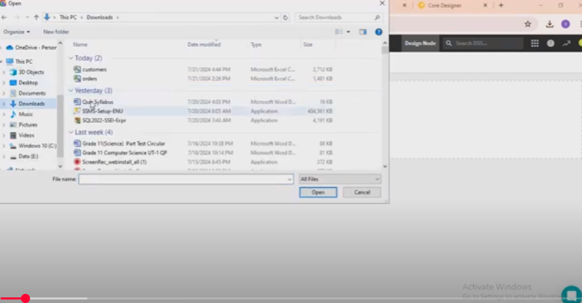

Next

Next

Next

Next

Next

Next

Next

Next

